E-COMMERCE FOR ELECTRICAL APPLIANCES

(TEAM6)

**MEMBERS- PRACHI OBEROI, TAMOJIT SAHA, TEHREEM PARVEZ**

Portal Login/Registration:

* We will be creating a user registration page with user requirements like first name, last name, email, password, address and we will add on the fields as per requirements.
* There will a login page which will take the username and password and there will be authentication system for the user login.
* There will reset password functionality in login panel .

User and Role Management: Admin user can manage the user's info, create new role and assign role to user

* There are three type of business roles in our system

**ROLE_ADMIN, ROLE_MANAGER, ROLE_USER**

* Each user have different facilities according to their user roles.

**ROLE_ADMIN**

* Admin has the function to create users and assign roles to those users.
* Admin has the function to create new categories
* Admin can perform all sorts of edit,delete,add operations on products
* Admin can change the transition states from draft to review to publish.

**ROLE_MANAGER**

* ROLE_MANAGER can add the products
* ROLE_MANAGER change the state of products from draft to review
* ROLE_MANAGER can view the user page also.

**ROLE_USER**

* All sorts of read operations.

**USECASE DIAGRAMS**

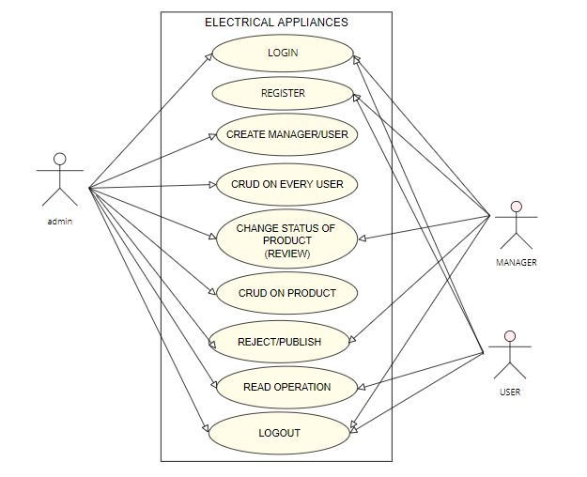

Product Data Modeling-

We have thought of creating the data schema as follows-

There will be three tables

**USER TABLE**

**CATEGORY TABLE**

**PRODUCT TABLE**

**RELATION BETWEEN USER TABLE AND CATEGORY TABLE**

* User id acts as foreign key for category table and there is one to many relationship between them because **one user can manage various categories**.
* Category id acts as foreign key for product table. There is on to many relationship between them because **each category can have many products**

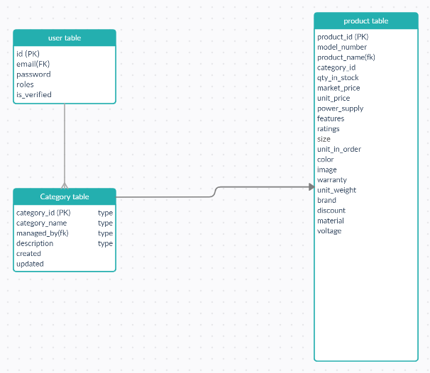

Product Create/Edit page: Design page to display product detail and edit page.

* We will be creating a controllers for displaying the product detail of category to the business managers according to their category assignation.
* Product listing will be done by different managers they can add, delete and manage products as per their requirements.

Product Listing Page

* 1. Design a page to list the products. Product listing should be restricted based on the roles.

**SOLUTION-**

We will be using a single controller or page for product display but we will be using various functions to show different user interface to the user as per their user_role.

* 1. User can delete one or multiple products from list page.

Business managers can delete the product from product listing page of their assigned category only.

* 1. Admin user should see all the products and assign one or multiple products to user.

Admin can assign multiple product category to the business managers once admin will assign tem product and their roles they will be notified via email and they can see the listings of all products.

**FLOW CHART FOR FUNCTIONALITIES**

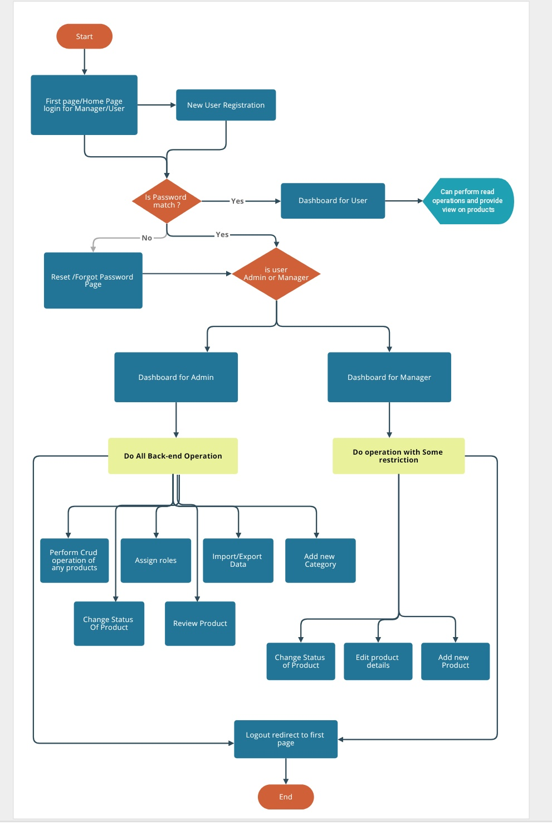

**Bulk Import**:

* 1. Backend system (Symfony Command) to import products and categories in bulk by reading the JSON

To import the inventory system into the database we will be creating json files.Importing of products can be done by business managers and super admin. Importing of categories can be done by super adminonly.

* 1. Aggregated import result should be logged in logger system, Monolog can be used

**SOLUTION-** Using logger bundle and creating a controller to create the aggregate result.

Workflow: Symfony workflow to manage product states like new/draft, review, published**.**

**Solution:-** We will create a workflow using symphony workflow bundle for changing the product states from one to another .Product will be prepersist as **new** once the admin/business manager will create it. It will be in **review** state once passed to managers and if they approve the product it will be in **published.**

Email Notification: User should be notified when product is assigned.

**Solution:-** Creating a event using mailer bundle that once the admin will create the manager .Manager will be notifed regarding their addition ,role assignation, and category they are assigned to.

Outbound API: Webservice API to expose product data to website**.**

We will be using rest api for this purpose.

**WIRE FRAME DIAGRAM**

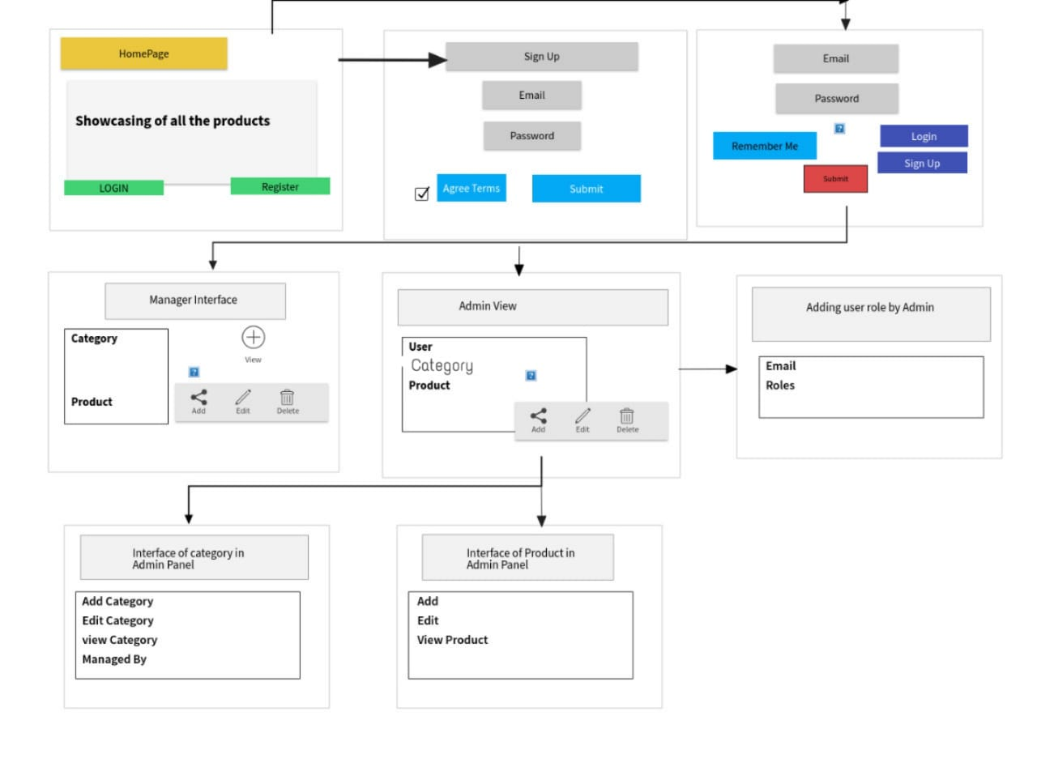

**WORK DONE BY FAR….**

* We have created a login and registration page along with reset password functionality
* On registration there is functionality of email notification.
* Database design is completed.
* We have created the wireframes and workflow diagram to understand the functionality and flow of the system.
* We created the entity class and added some attributes to check the functionality of keys and relationships in database.
* We also created the list of products to showcase it on the home page.
* We worked upon role persmissions access also.

**DATED -21/1/2021**

* Today we started our work with assigning the roles to different users.
* We worked upon the feature of admin having the functionality of changing roles.
* We created the admin interface today in which we added the functionality of adding category by the admin.
* Admin was also to perform all sort of crud operations on User,Product as well as Category entities.
* We worked upon json format of files to import the data in bulk into the database.
* Json file is importing the data according to the fields specified in sequencial manner.
* We have also worked upon base encoding of image while loading the image data into database so that database can read it correctly .
* We have provided this functionality to admin only .
* We also created event subscriber to set the workflow of the product in different phases.

As of now, we are working on Api to export the data also

**DATED 22/january/2021**

**DATABASE TABLE EXPLAINED-**

**User Table-**

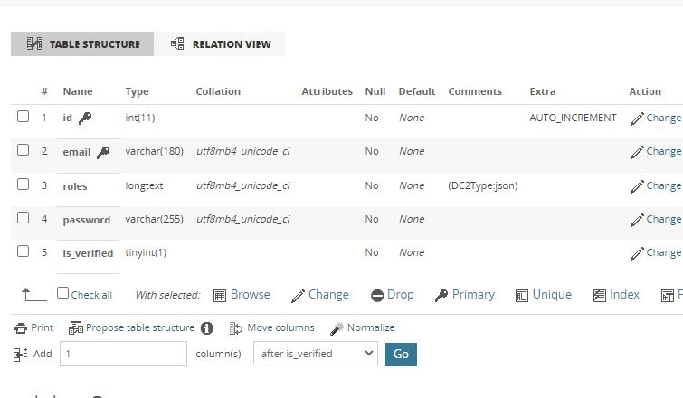

***CATEGORY TABLE***

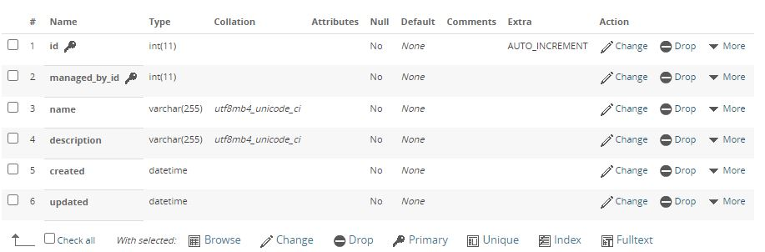

**Product table**

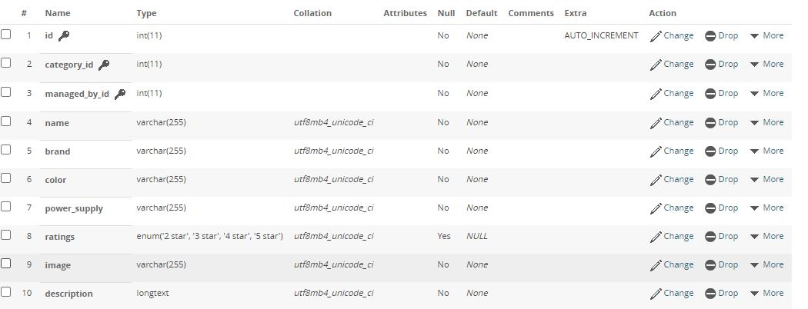

**PRODUCT TABLE CONTINUED-**

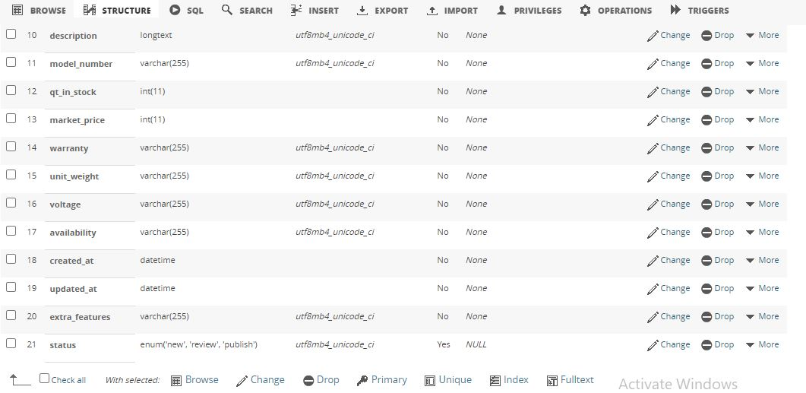

**Screens of work done so far…**

**Registration page-**

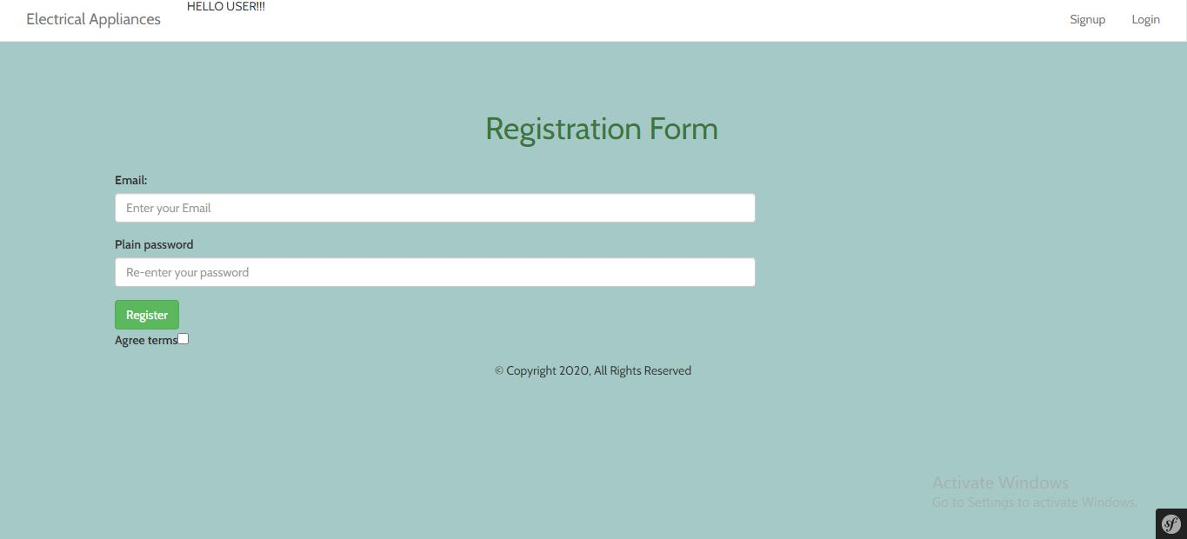

**LOGIN PAGE**

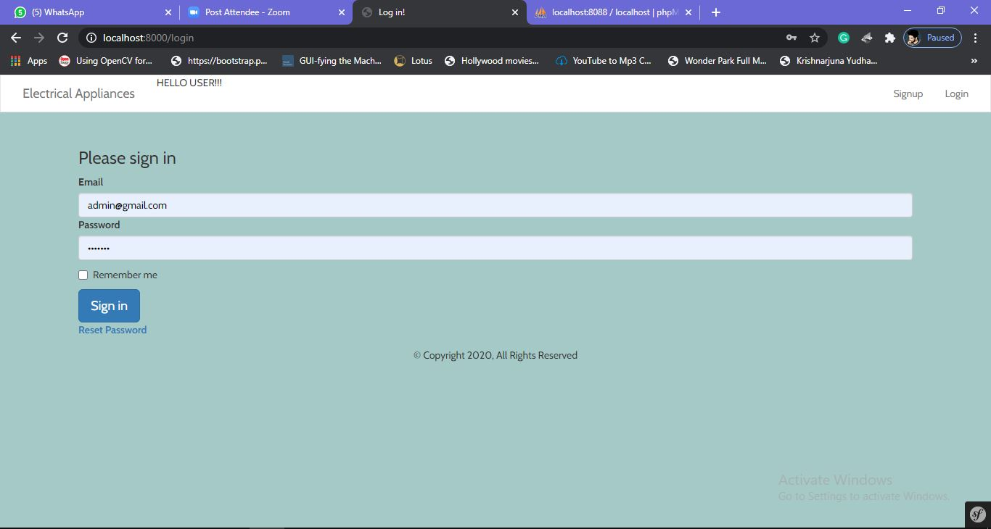

**HOMEPAGE SCREEN-**

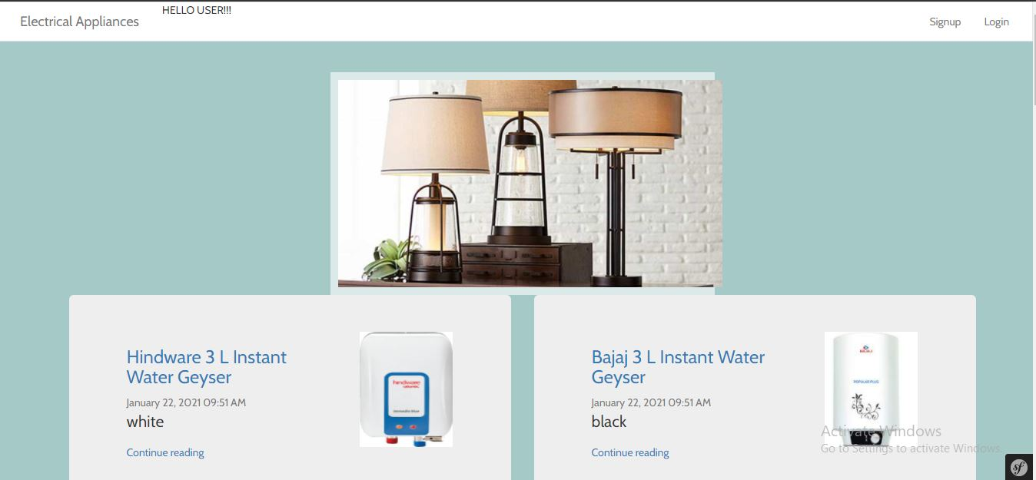

DASHBOARD FOR ADMIN

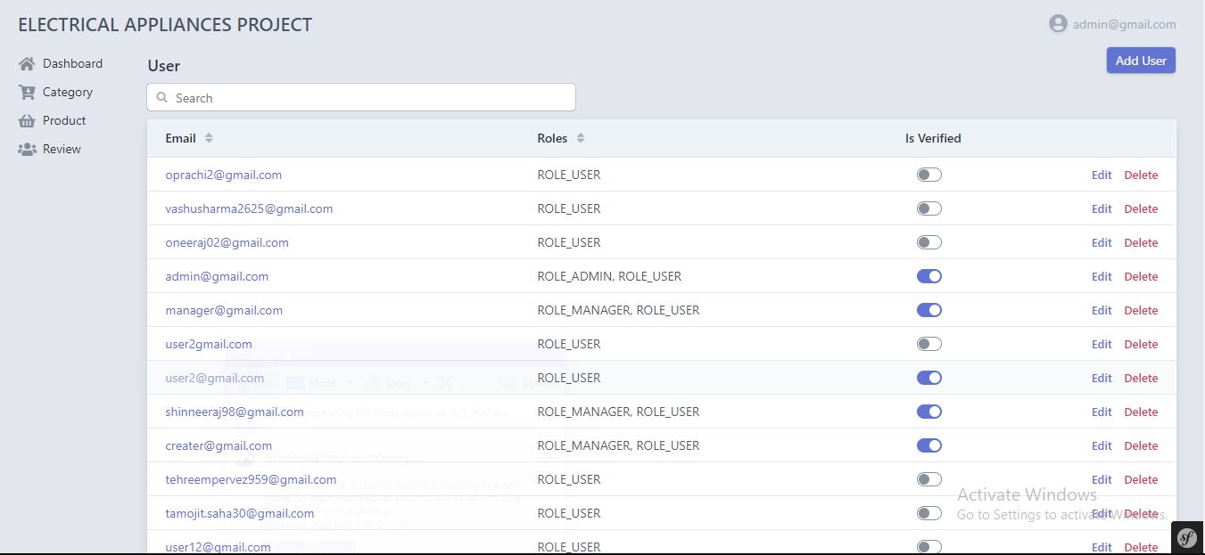

PRODUCT INTERFACE FOR ADMIN-

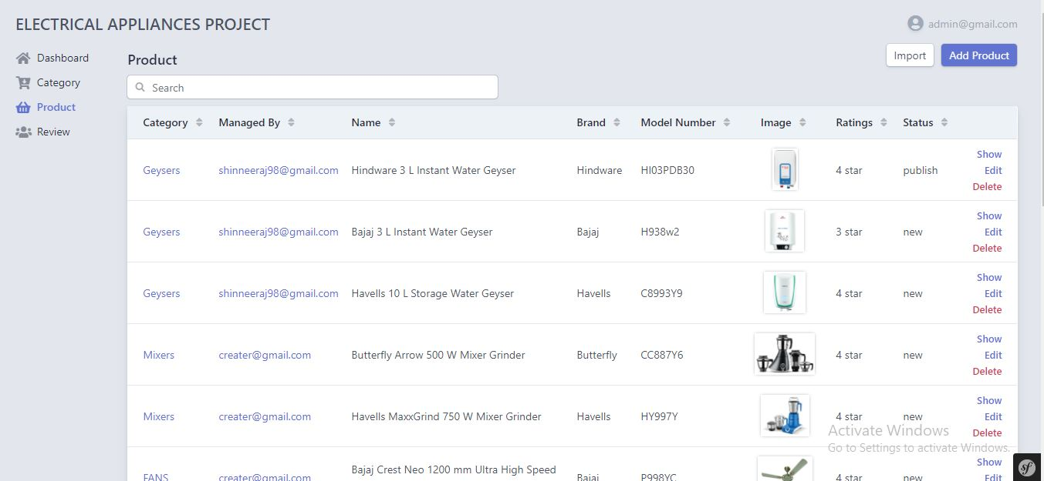

CATEGORY INTRFACE FOR ADMIN-

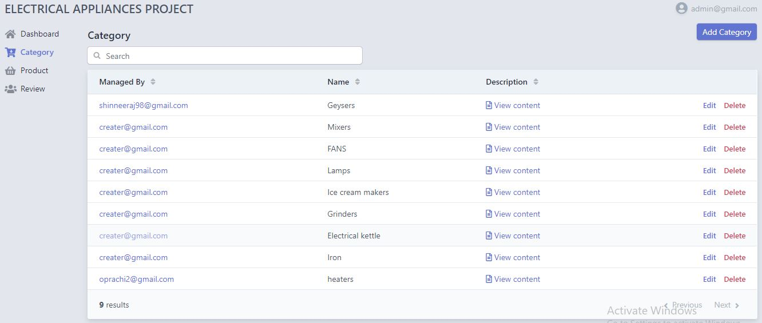

WORK DONE TODAY-

* We have worked upon creating the manager interface and handling all crud operations by a manager.
* We have build a api controller which is fetching all the data from the product table through response in JSON format.
* We are able to export the data correctly through **POSTMAN.**
* We have added the show button in product interface because showing all the attributes in one page it was not looking fine. So, when the user will click on show button then only user can see all the attributes.
* In user interface, user have the accessibility to see all the products.
* To maintain the work flow , whenever the new product is added, it is pre persisted in ‘new’ category . Manager have the authority of changing the status of product from ‘**review**’ to ‘**publish**’.
* We are working upon creating a log table for storing the information of manager who is editing the products.

FINAL INTERFACE FOR THE PROJECT

Homepage-

* This is the very first interface of our system which the user will see after visiting our website. Anonymous user can see the home page and see the products mentioned over there.

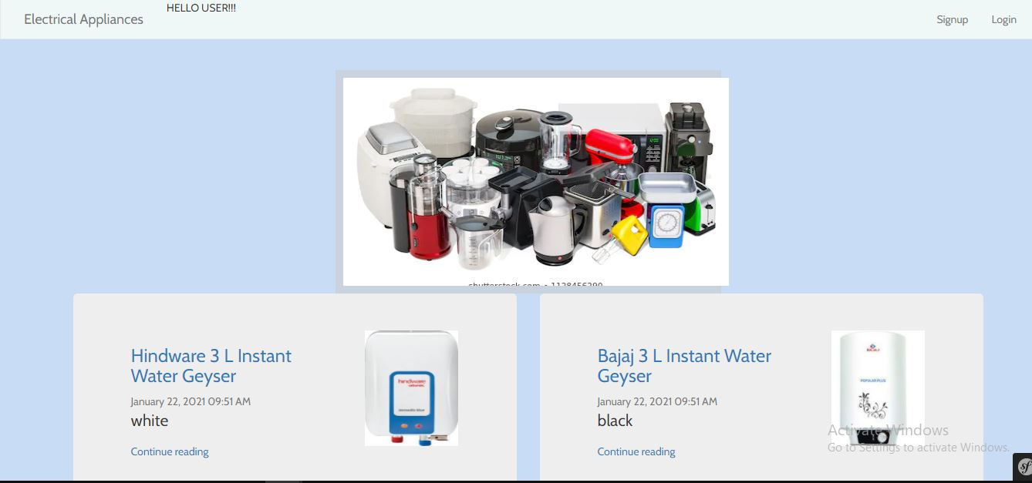

**Registration Page**

* In the navigation bar we have provided the route for registration page, After clicking on signup button user can see the register interface
* After user registers with their respective email id and password a verification link is sent to the mentioned email id for their confirmation.
* Admin don’t need to register , as we have hardcoded the admin user id and password in our system.

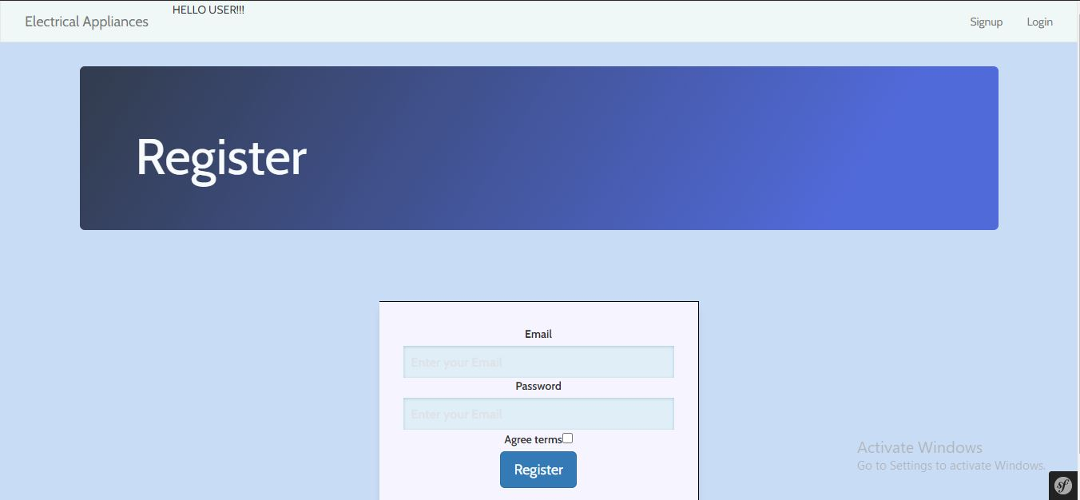

**LOGIN PANEL-**

* After the successful registration user will be redirected to the login interface.
* We have three types of user roles in our system ROLE_ADMIN, ROLE_MANAGER,ROLE_USER.
* So, after successful login user will be redirected to the dashboard according to their user roles.



**RESET PASSWORD-**

* We have provided the functionality of reset-password in case user have forgotton their password.
* After clicking on reset-password button user be rdirected to reset password url.

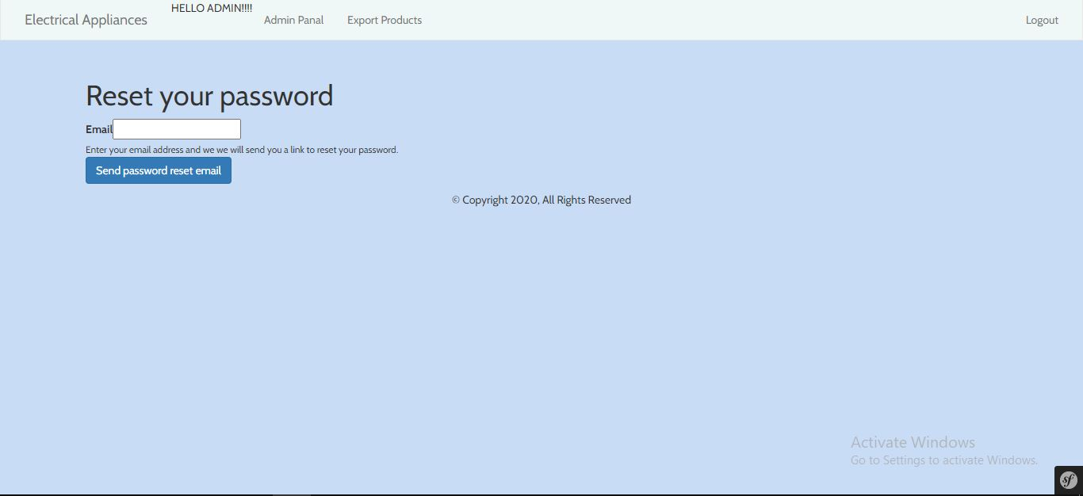

* After user mention their respective email id a reset password link will be sent to the user.

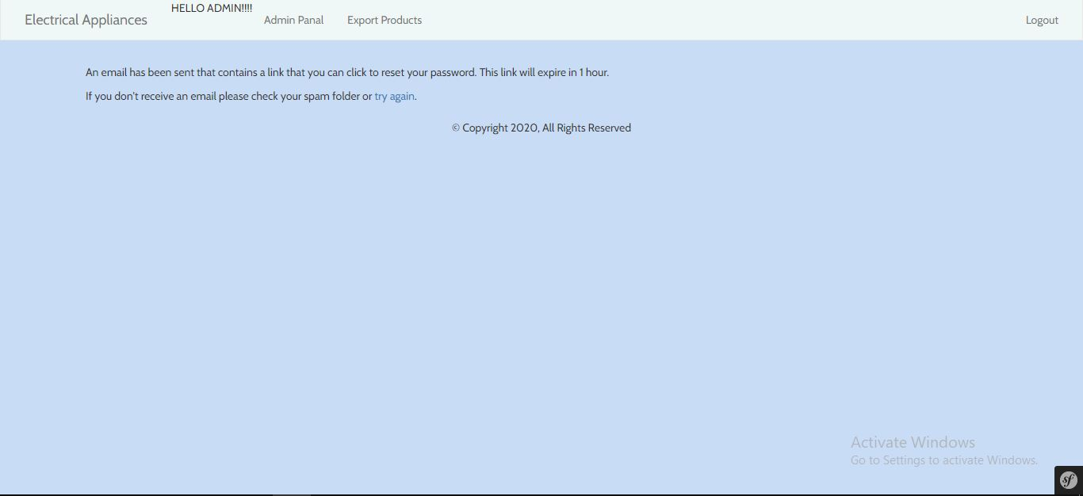

* For the demonstration purpose a reset password message will look something like this to the user when the user will click on the url given in email they can change their password.

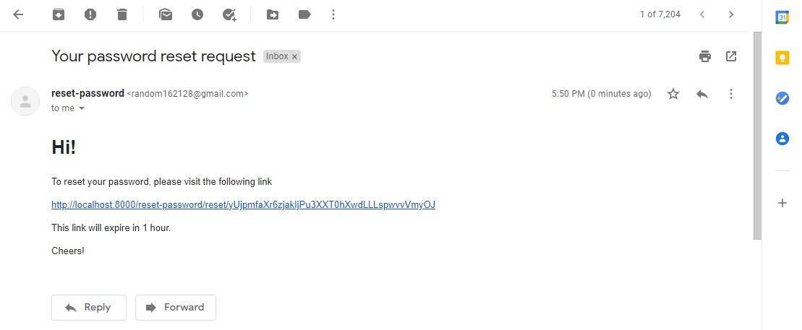

**ADMIN INTERFACE-**

* After admin login with their user id they will be redirected to the admin dashboard
* Admin can see the user information on their dashboard panel.
* Admin can assign roles to registered user like (role_manager).
* Admin have the functionality of editing user roles and deleting users if admin find it inappropriate.

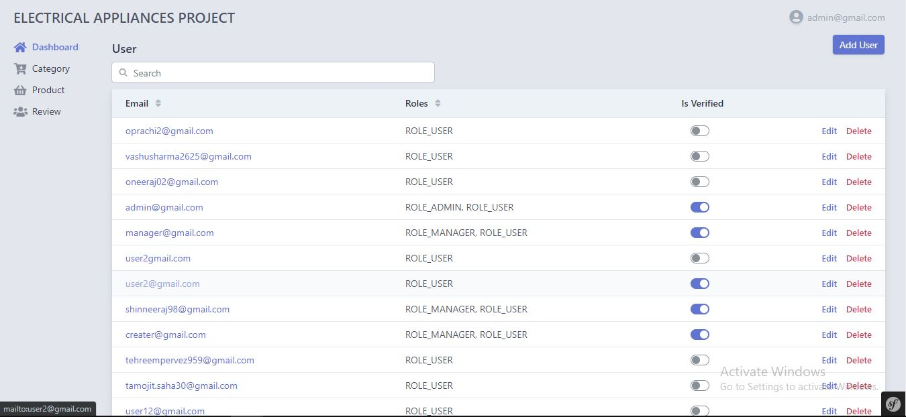

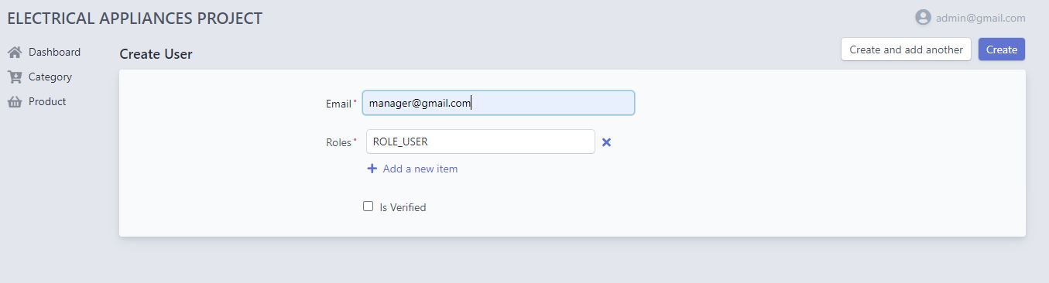

**CATEGORY INTERFACE FOR ADMIN-**

* Admin can see the categories information present in the system
* Admin can edit and delete the category information.
* Admin can add a new category and while adding a new category admin can assign that category to a manager.

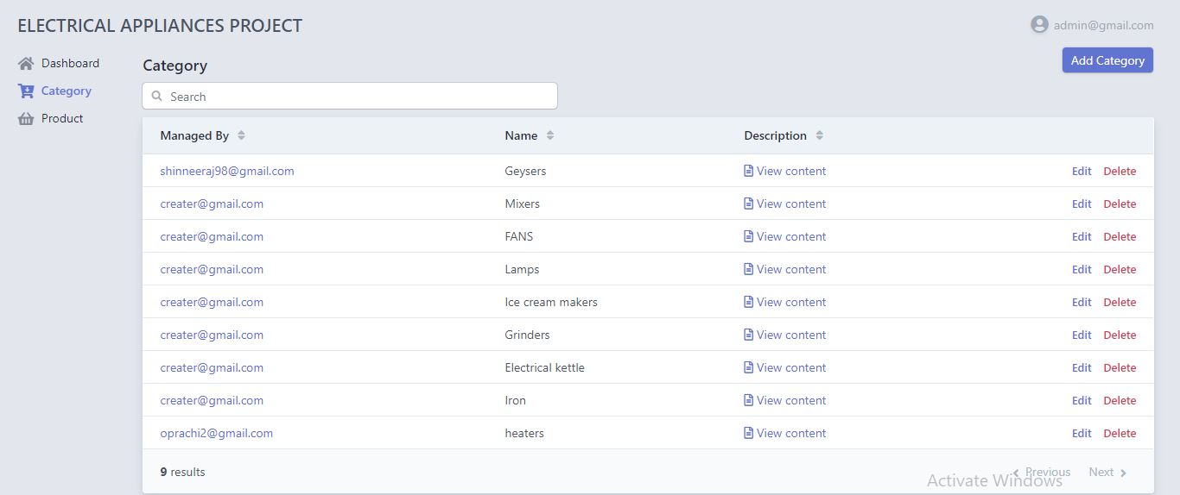

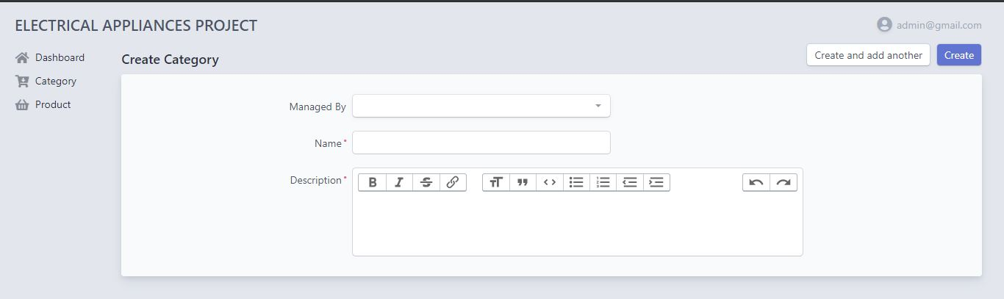

**Product Panel-**

* In product interface for admin , admin have the accessibility to perform all sort of crud operations on product.
* Admin can add, edit and delete the products.
* We have added a show button functionality, because showing all the attributes of products in single page is not a great implementation so when the user will click on show button then only user can see all th attributes of a product.

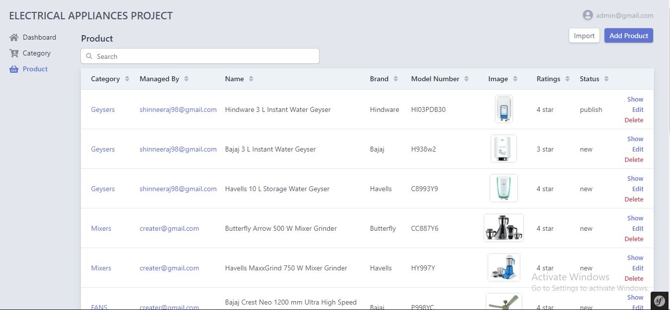

**SHOW BUTTON FUNCTIONALITY-**

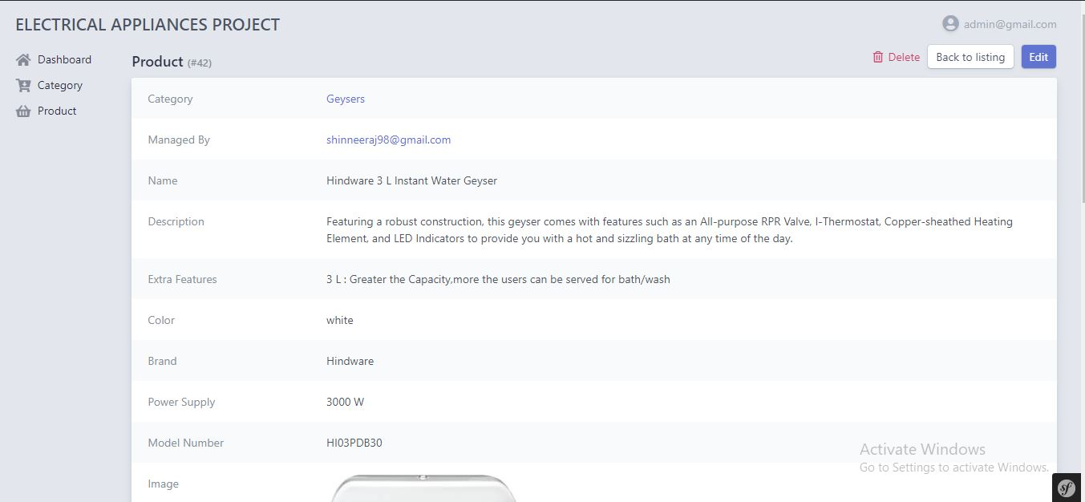

**IMPORT OF BULK DATA-**

* We have added the functionality of adding bulk data through import button.
* For this we have created the importpost function, that function is receiving all the data from given file and encoding all the attributes of product entity in json format.
* If the data is decoded successfully, you will be prompted with a message that product is imported successfully.

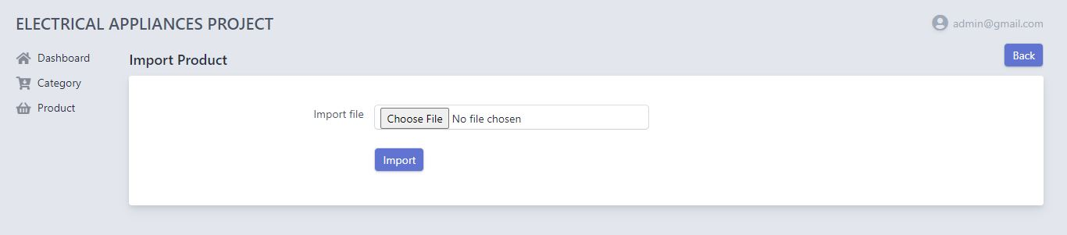

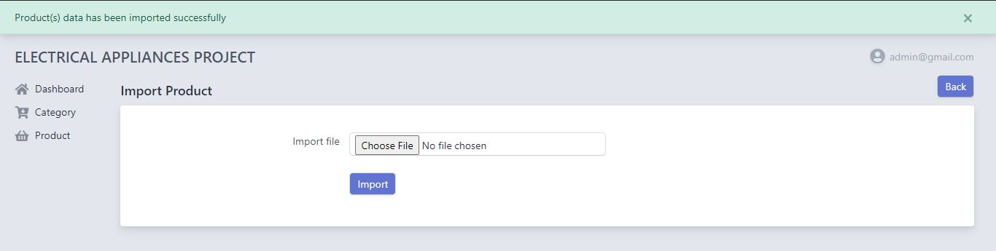

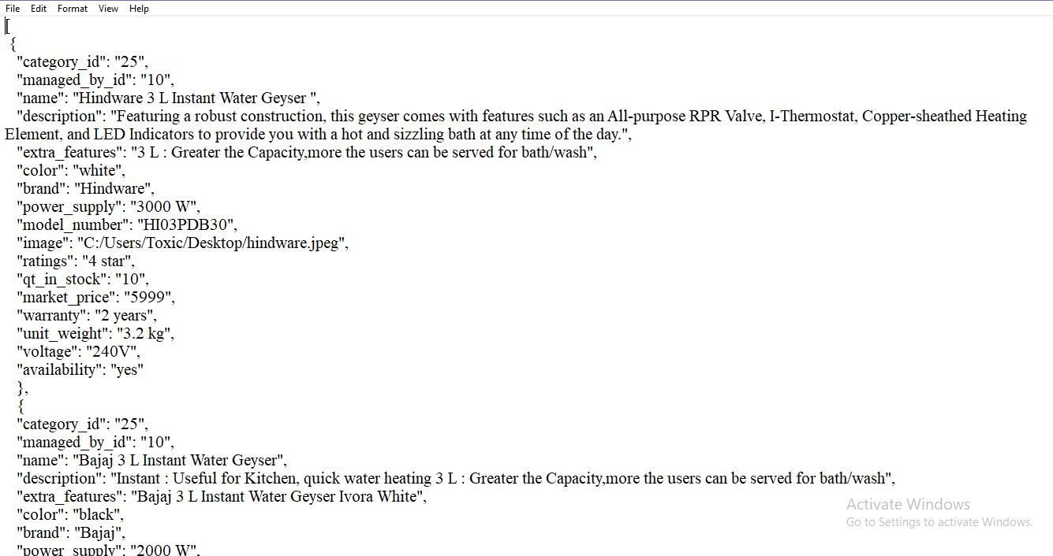

**Export functionality of Admin-**

* Functionality of importing the product data is given to admin only
* For the export purpose, we have created a function in product entity to change the product data to array.
* Also, we created the api controller to fetch the publish product data in json format.
* Through postman api we are receiving the output through get request and mentioning the route passed in the crud controller.

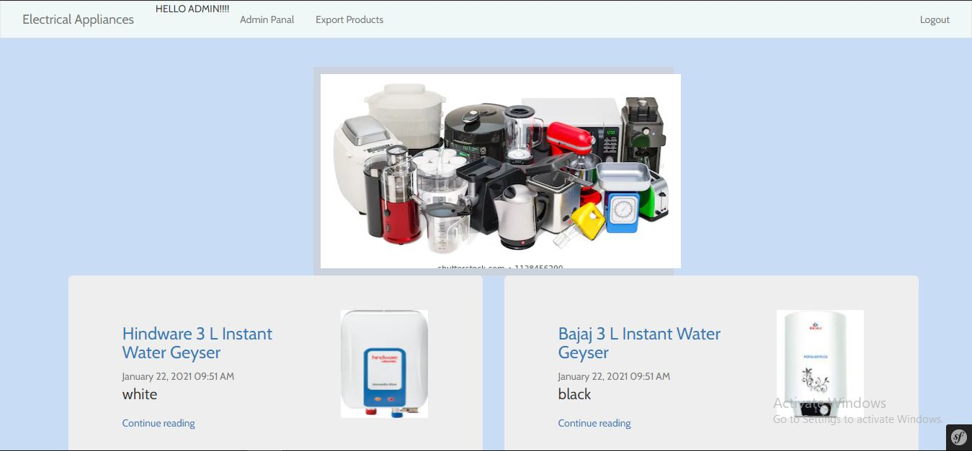

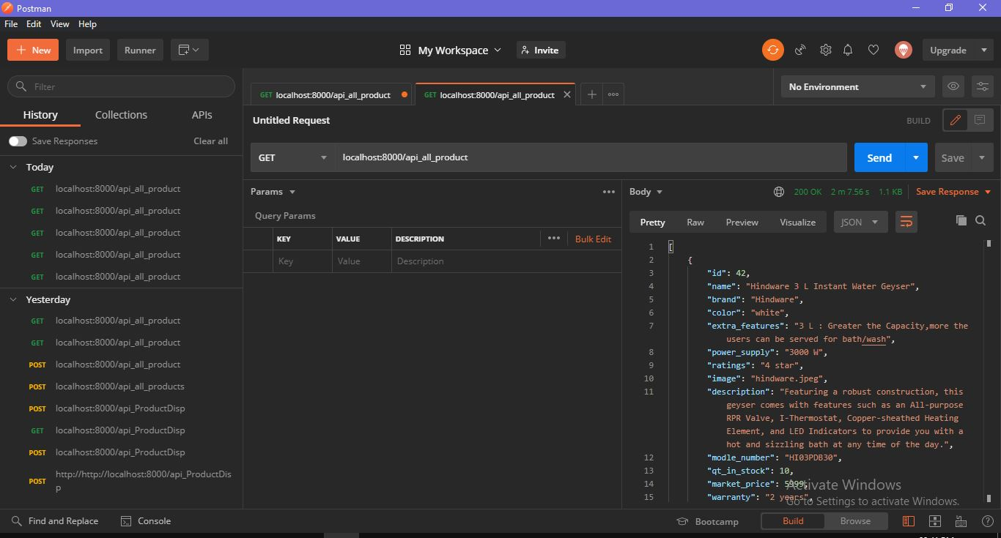

**MANAGER INTERFACE-**

* After logging in with respective email and password manager will be redirected to their dashboard
* Manager don’t have access permission to see the user information
* Even if they want to redirected to user information they will be prompted with the message of permission denied.

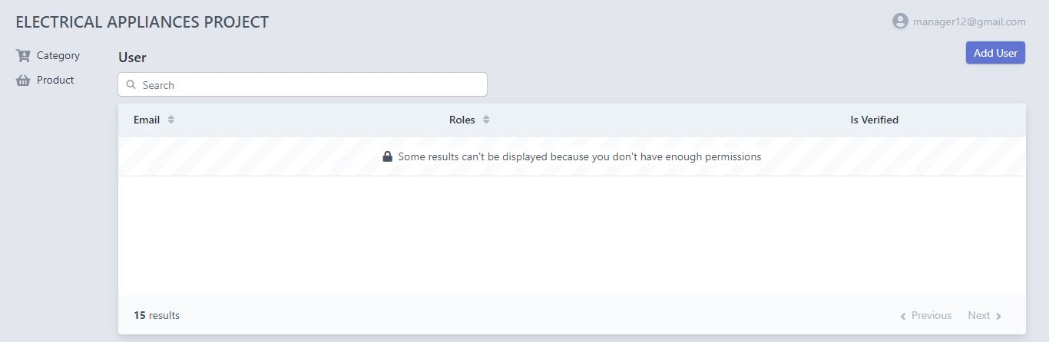

**Category Module**-

* In the category interface, Manager can see the category information but they don’t have access to edit and delete the category.
* Manager have the all the rights to do sort of crud operations on products.
* Manager can edit the product and can change the state of product from review to publish.

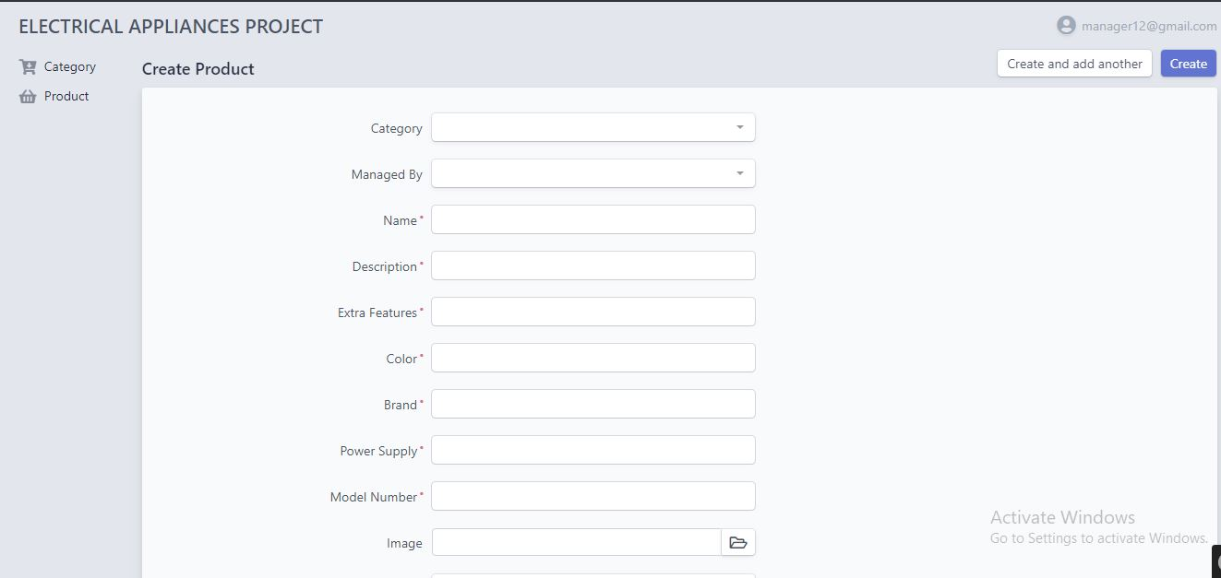

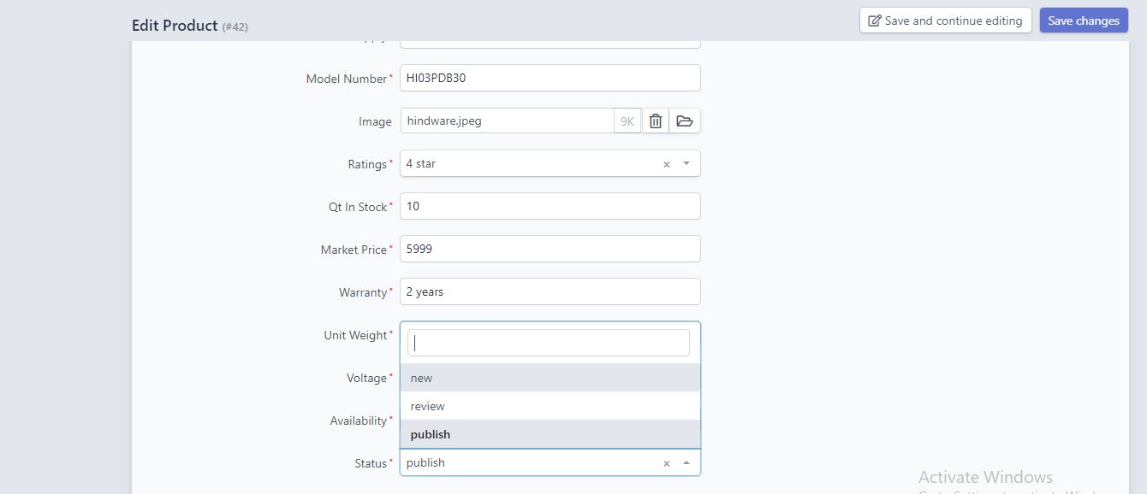

**USER PANEL**-

* User have the access to see the products and when they click on continue reading they can see all the attributes or product detail.

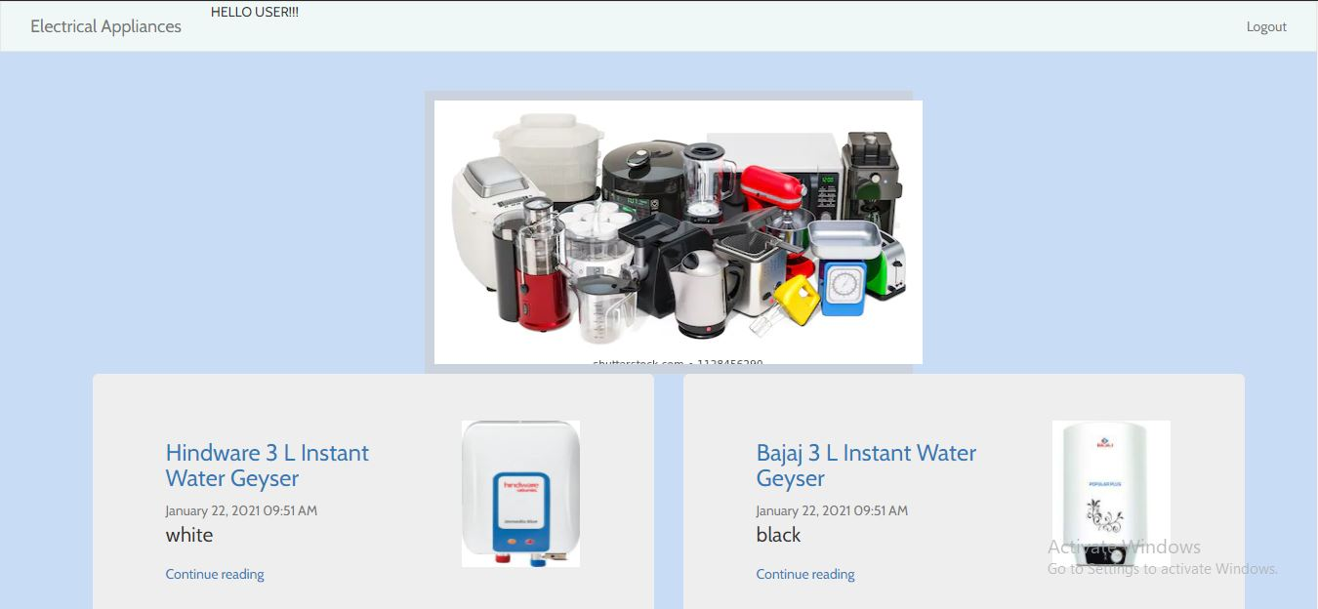

Work done today-

Dated 23/1/2021

* We worked upon api controller to export data
* We worked upon creating logger interface to export the data
* We worked upon interface of the project